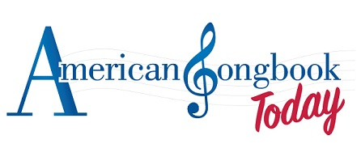
A 501(c)(3) not-for-profit presents
“An Evening of Oscar-Winning Songs”
Thurs, Feb 21st, 2019, 8PM
Nighttown, 12383 Cedar Road, Cleveland
“Gigi,” “Moon River,” “The Way You Look Tonight,” “All the Way,” “Call Me Irresponsible,” “Evergreen,” “It Might As Well Be Spring,” “Over the Rainbow,” “Swinging on a Star,” and many more.
Starring
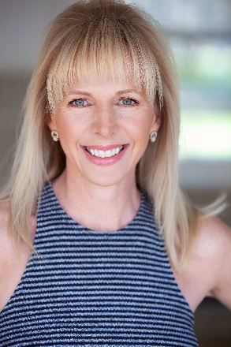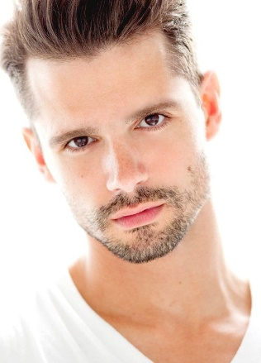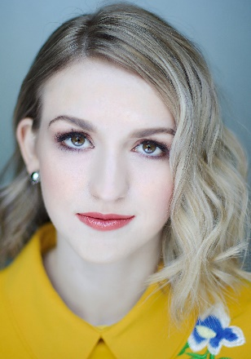
Lindsey Mitchell – Sunset Boulevard (Betty), Aspects of Love, International Tours, Toronto; Ruthless (Judy Denmark, Ginger DelMarco), Beck Center; Featured Soloist - Cleveland Pops & The Musical Theatre Project
Robb Sapp – Broadway: Wicked (Boq opposite Idina Menzel) The Lion King, Shrek. Part of the original creation of 25th Annual Spelling Bee and Spring Awakening. Robb often teaches and directs in Cleveland.
Sami Kennett – A sophomore in the BFA Musical Theatre program, Kent State; recently starred as Lili in Near West Theatre’s production of Carnival and Hazel in Rodgers & Hammerstein’s Allegro at Kent State.
Hosted by AST Founder/President, Michael Estwanik
Piano - Bob Navis, Jr., Near West Theatre’s Artistic Director
Tix: $25 http://nighttowncleveland.club/
https://www.americansongbooktoday.org/

